CRUD APIs operations to Mastaon

## [Github Repository Link](https://github.com/bhusalashish/Mastodon-API-272-HW/)

## Home Page:

## 

Figure 1.1

Figure 1.1 shows our simple UI for interacting with Mastodon's three APIs: Post, Get, and Delete. At the top, three elements show the user information based on their service. Refer to each service section to see what it does. In the middle, there are our three services.

* Post, allows the user to post text into our Mastodon account by typing their post and pressing the submit button
* Get, allow the user to enter the post id to retrieve their post and show its content. They do this by entering the post ID and press get status
* Delete, allows the user to delete their Mastodon post by entering the post ID and pressing the delete button

At the bottom of the page, we have a list that shows the Post ID of the user. It helps users to search and delete their posts. There is a button to copy the ID.

## Post:

To create a post, follow these steps:

1. Write the post on the ‘Enter your post’ box and press the Submit button

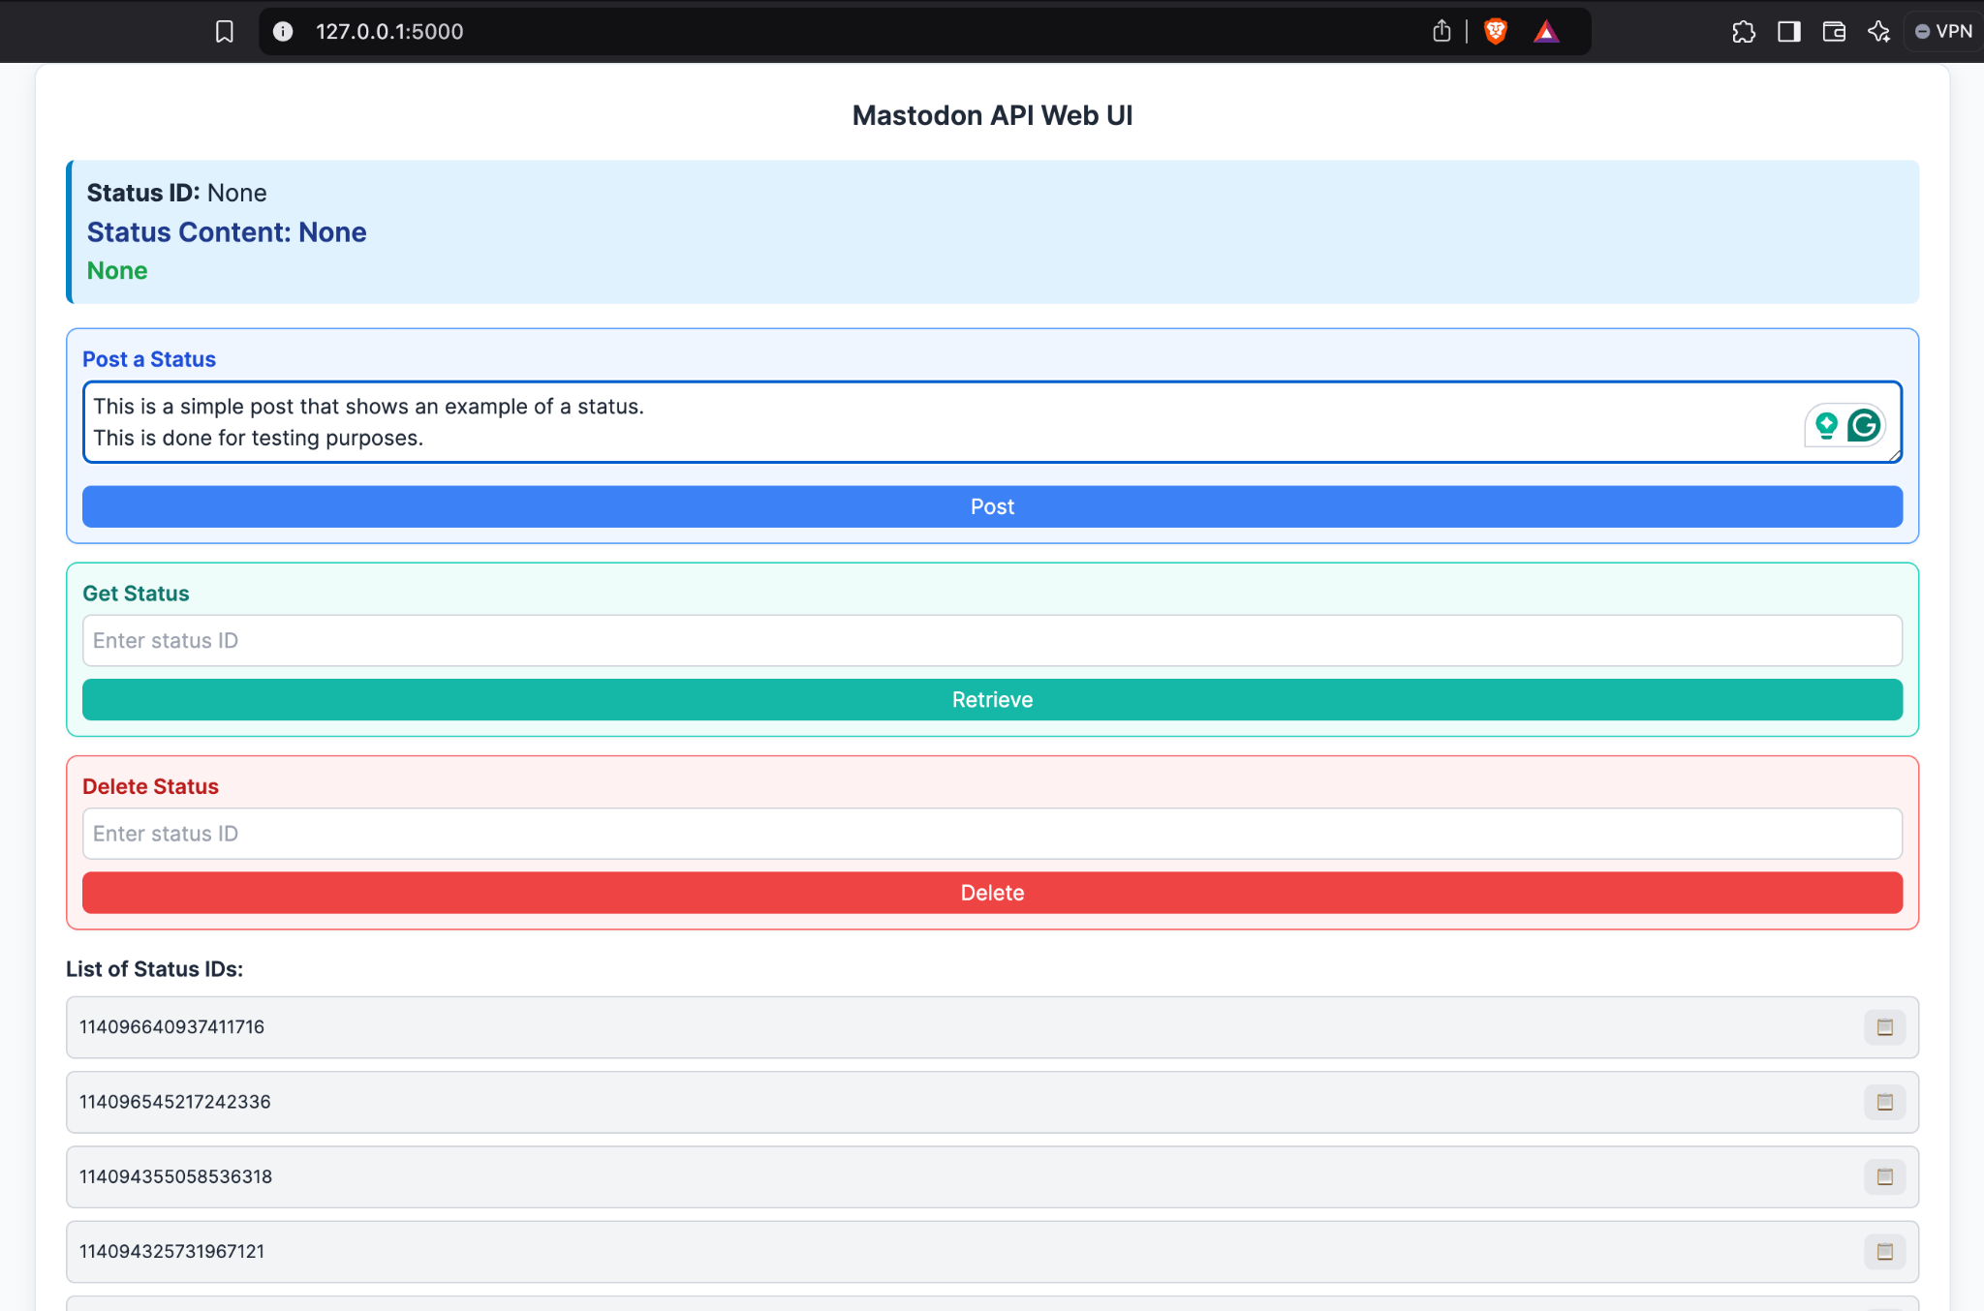

Figure 2.1

1. The UI will show the Post 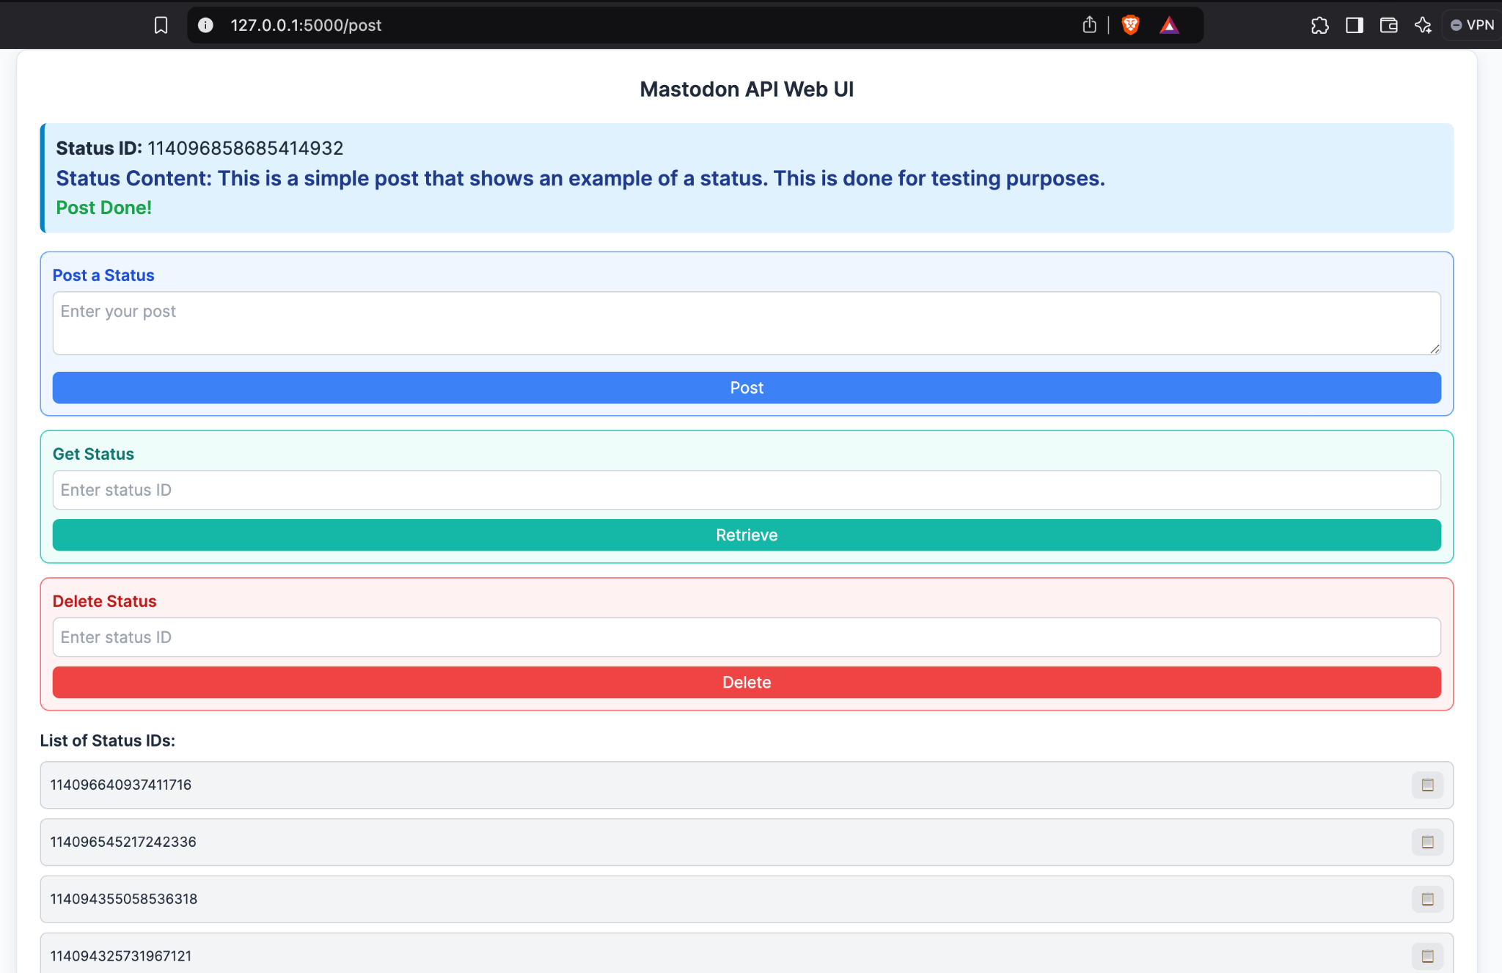

Figure 2.2



Figure 2.3 Post is uploaded to Mastodon

Mastodon limits the number of characters for each post to 500 characters and it cannot be empty. Figure 2.3 and Figure 2.4 show how our UI handles it

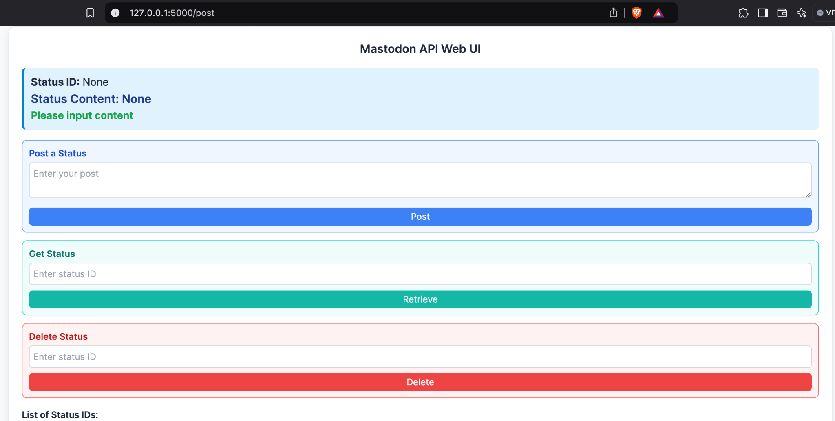

Figure 2.4 Post content is empty

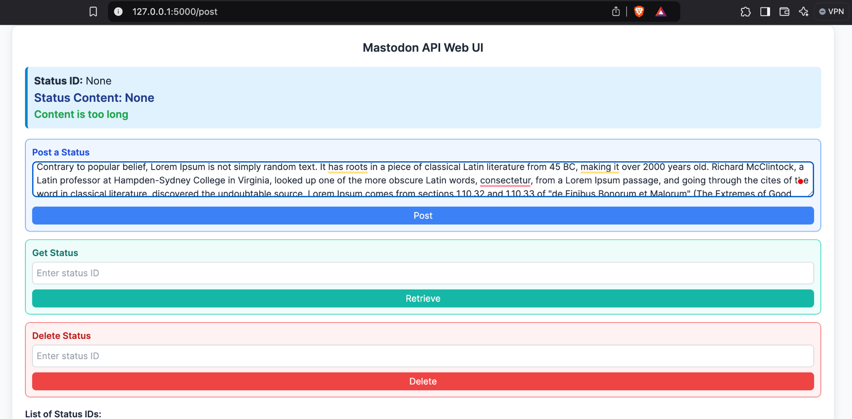

Figure 2.5 Post content is too long

## 

## Get:

To retrieve the post, follow these steps.

1. Enter the Post ID listed in the List of IDs and press the Get Status button

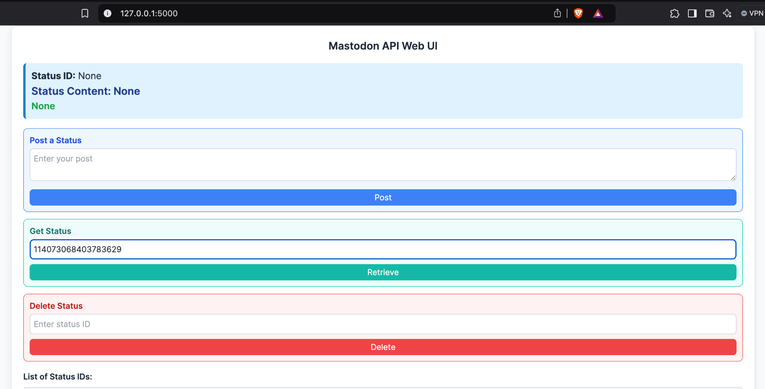

Figure 3.1 Entering Post ID

1. The UI will show the Post content

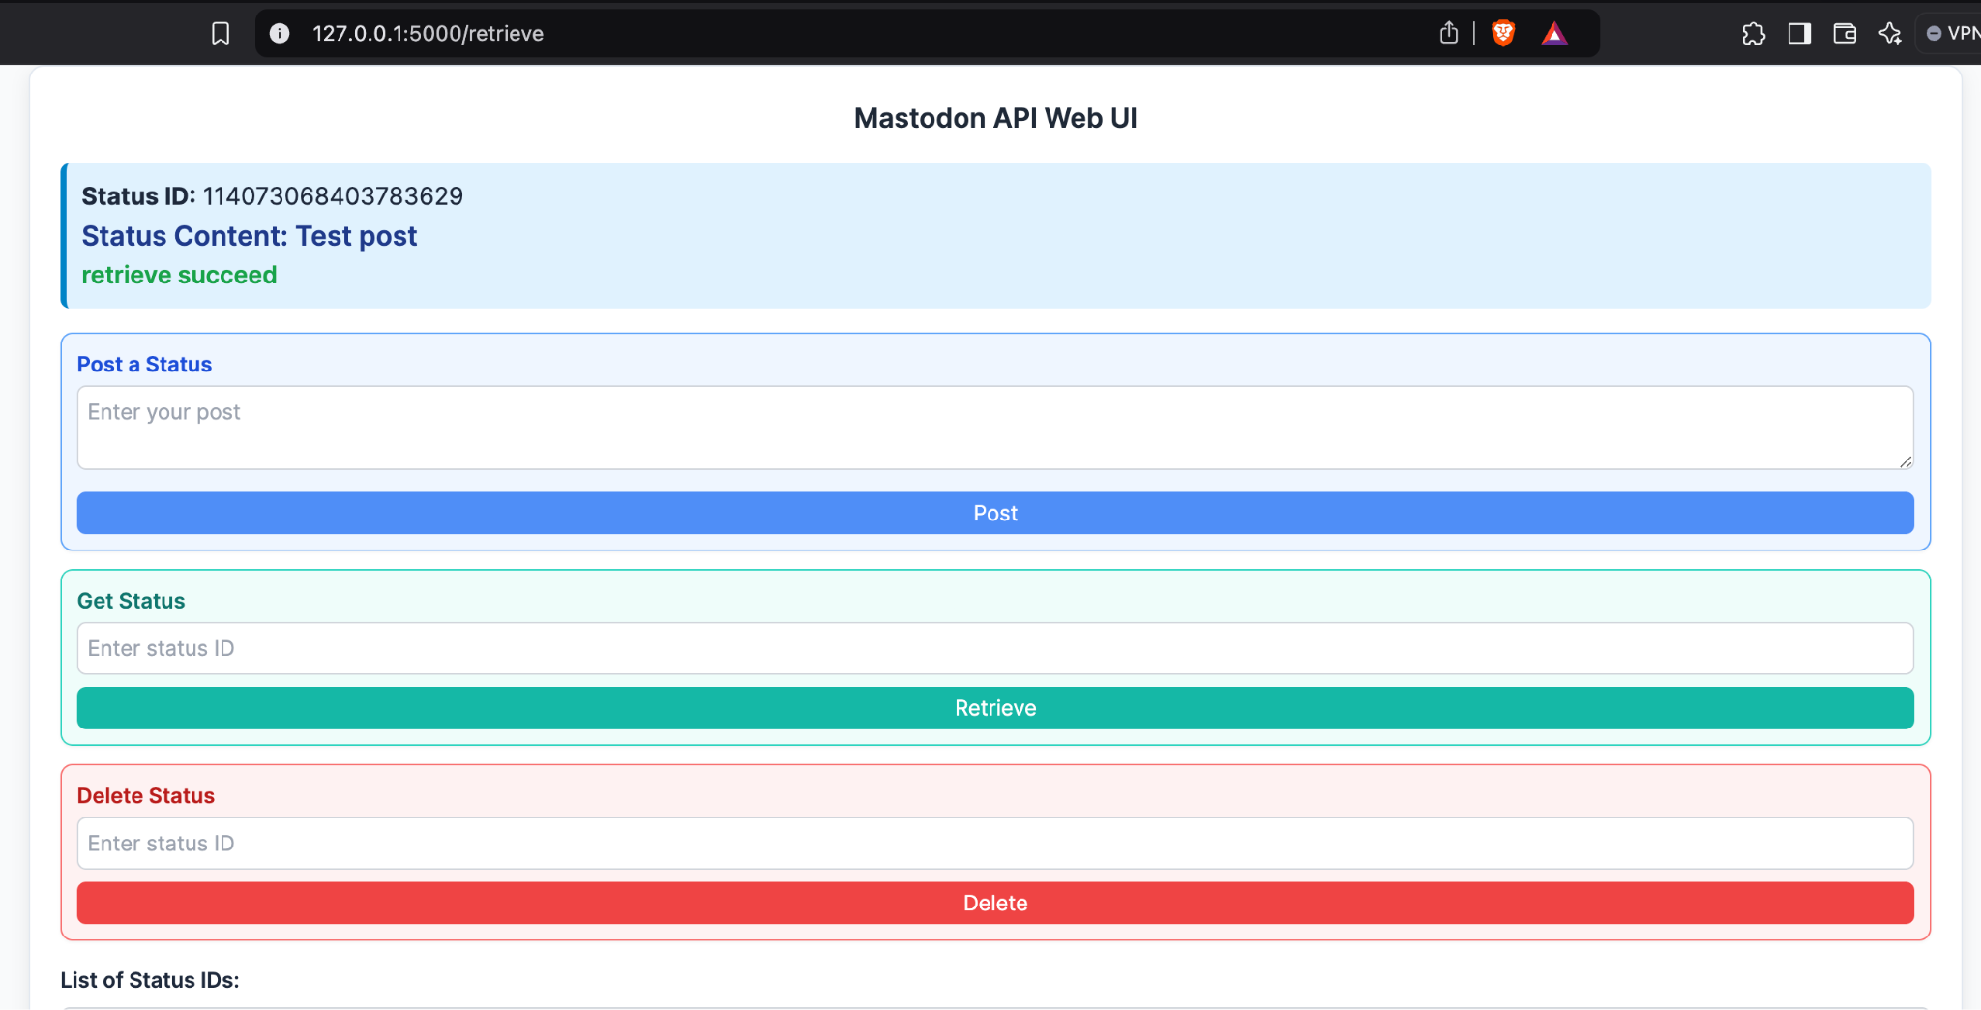

Figure 3.2 Search Result



Figure 3.3 The post in Mastodon

If a user enters an invalid ID, The UI will show the following.

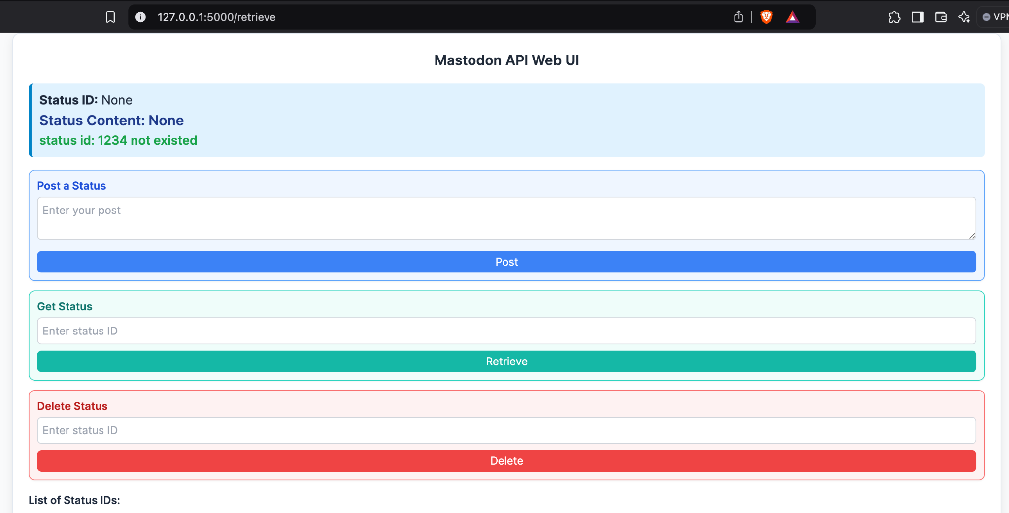

Figure 3.4Invalid Post ID

## Delete:

To delete a post, follow these steps:

1. Enter the Post ID listed in the List of IDs and press the Delete button

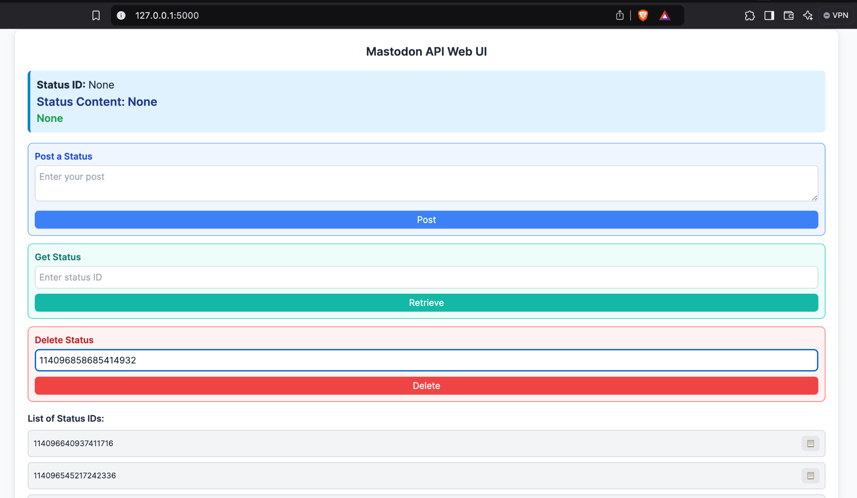

Figure 4.1 Enter the Post ID

1. The UI will show the following if successful

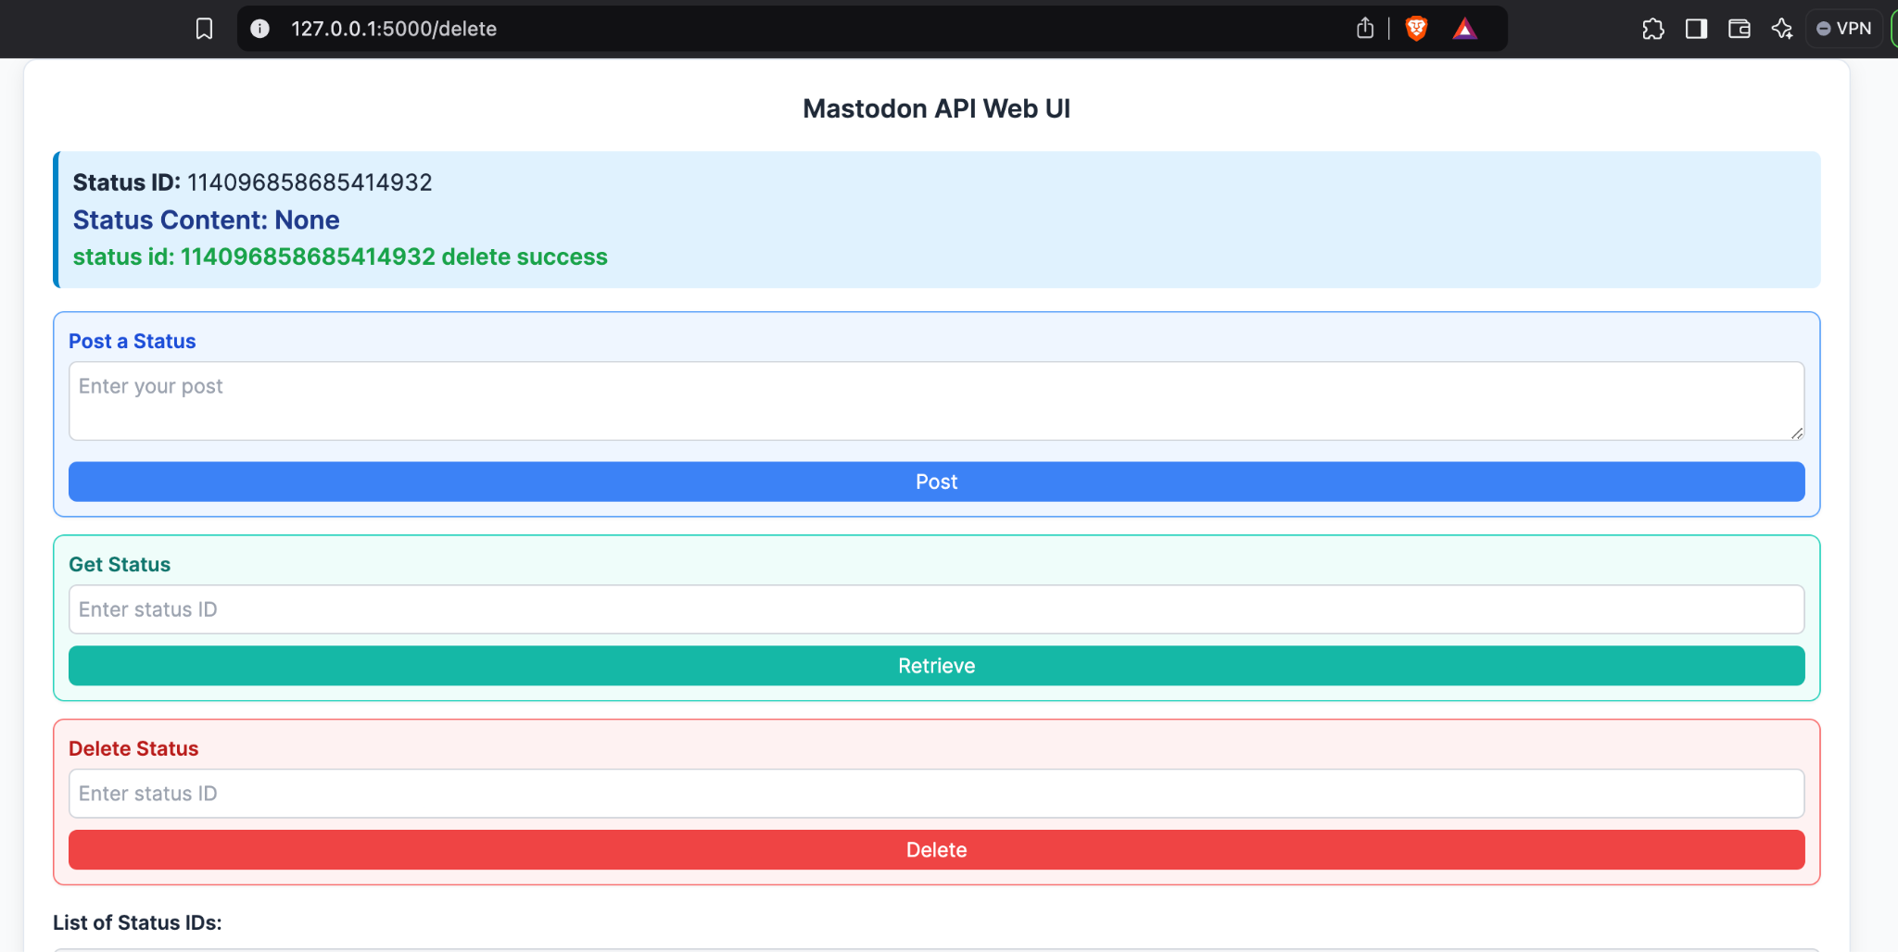

Figure 4.2 Post is deleted

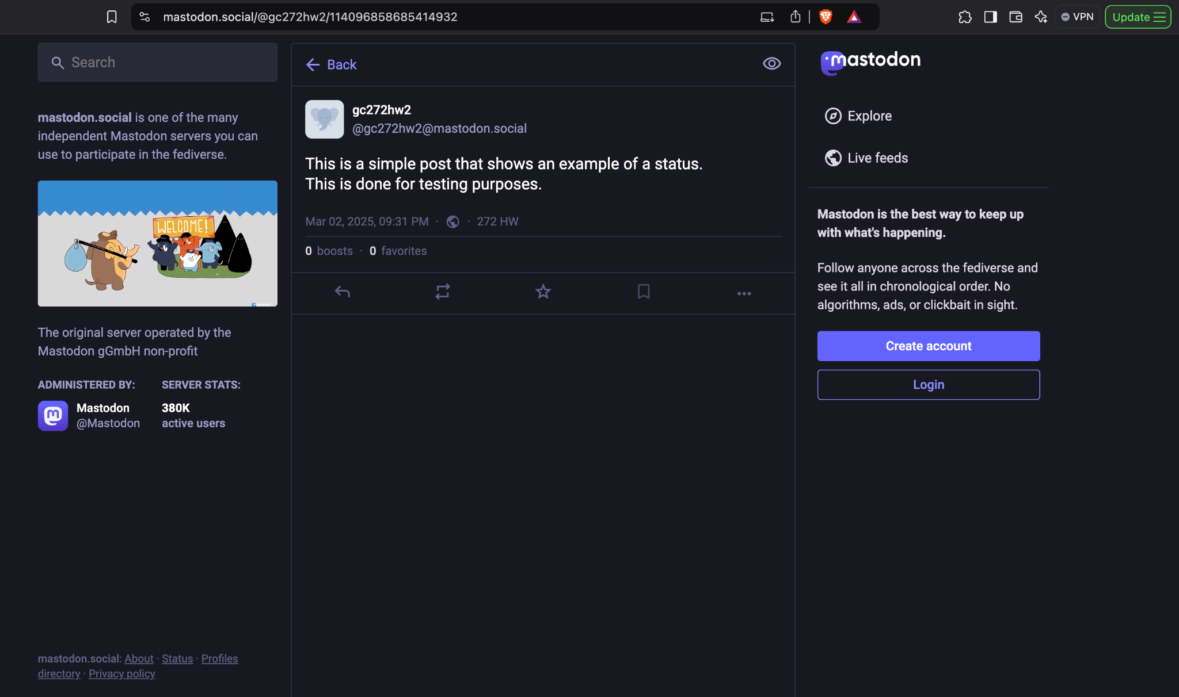

Figure 4.3 Before deleting the post



Figure 4.3 Post is deleted from Mastodon

If the user tries to delete an invalid ID, the following will be displayed

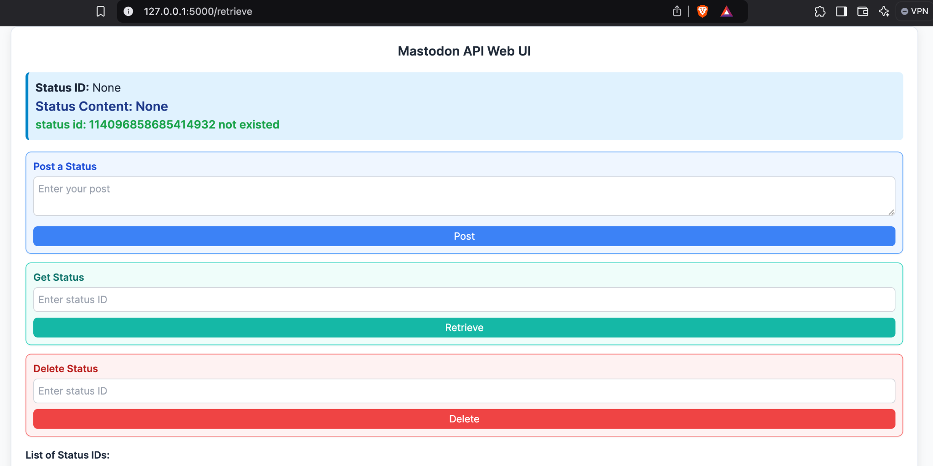

Figure 4.4 User entered an invalid ID to be deleted